**Lab 13**

**To Explain the Types and Working of Digital Counters and Implement Binary Counter Using IC**

**Note: For all the circuits in the tasks, your logic diagrams should be either hand drawn or from the software logicly. Keep them neat and legible. These circuits will be having many connections so, for simulations, make sure that you label the inputs and outputs clearly. Use Label tag in “logically”. You can also edit the pictures of your outputs in “paint” easily.**

**Tasks**

1. **Construct a logic circuit for 4-bit Asynchronous Counter using JK Flip Flop. Simulate your circuit to verify the outputs.**

4-Bit Asynchronous Counter Using JK Flip Flop

1. Logic Diagram

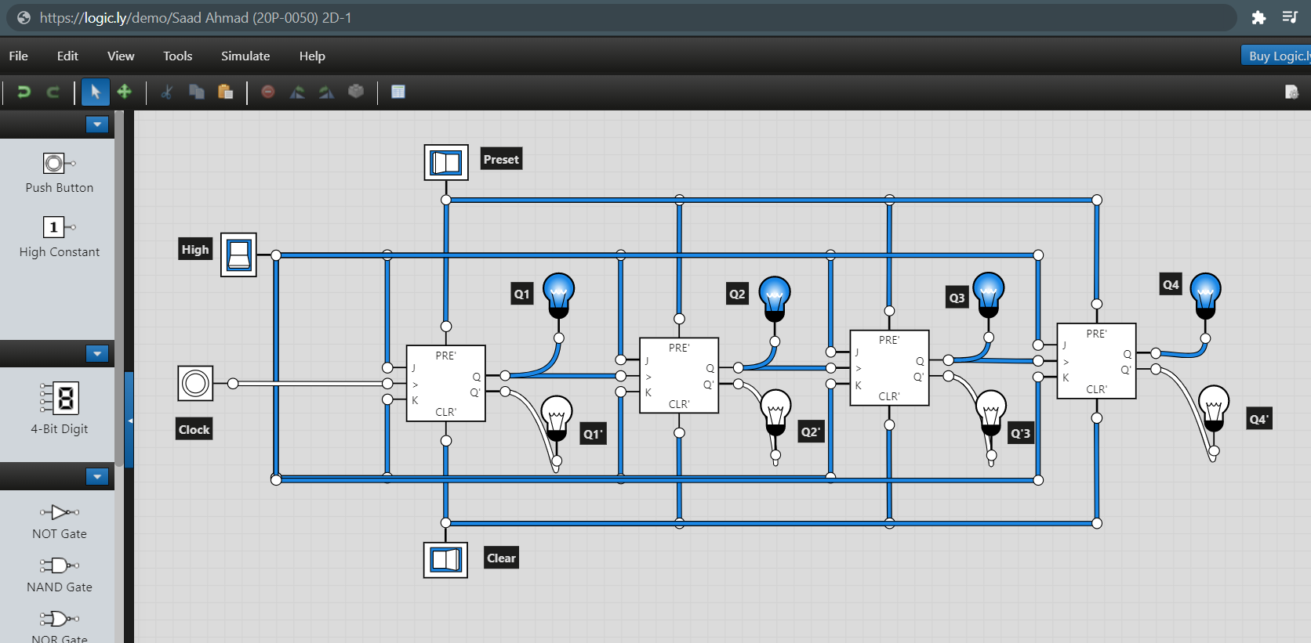

1. Truth Table

|  |  |  |  |  |  |  |  |  |  |
| --- | --- | --- | --- | --- | --- | --- | --- | --- | --- |
| Clock | Decimal | Q1 | Q2 | Q3 | Q4 | Q1’ | Q2’ | Q3’ | Q4’ |
|  | 0 | 0 | 0 | 0 | 0 | 1 | 1 | 1 | 1 |
|  | 1 | 0 | 0 | 0 | 1 | 1 | 1 | 1 | 0 |
|  | 2 | 0 | 0 | 1 | 0 | 1 | 1 | 0 | 1 |
|  | 3 | 0 | 0 | 1 | 1 | 1 | 1 | 0 | 0 |
|  | 4 | 0 | 1 | 0 | 0 | 1 | 0 | 1 | 1 |
|  | 5 | 0 | 1 | 0 | 1 | 1 | 0 | 1 | 0 |
|  | 6 | 0 | 1 | 1 | 0 | 1 | 0 | 0 | 1 |
|  | 7 | 0 | 1 | 1 | 1 | 1 | 0 | 0 | 0 |
|  | 8 | 1 | 0 | 0 | 0 | 0 | 1 | 1 | 1 |
|  | 9 | 1 | 0 | 0 | 1 | 0 | 1 | 1 | 0 |
|  | 10 | 1 | 0 | 1 | 0 | 0 | 1 | 0 | 1 |
|  | 11 | 1 | 0 | 1 | 1 | 0 | 1 | 0 | 0 |
|  | 12 | 1 | 1 | 0 | 0 | 0 | 0 | 1 | 1 |
|  | 13 | 1 | 1 | 0 | 1 | 0 | 0 | 1 | 0 |
|  | 14 | 1 | 1 | 1 | 0 | 0 | 0 | 0 | 1 |
|  | 15 | 1 | 1 | 1 | 1 | 0 | 0 | 0 | 0 |

1. Software Simulation



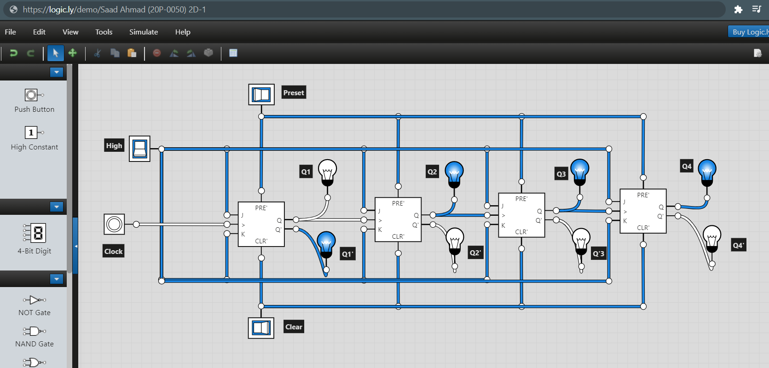

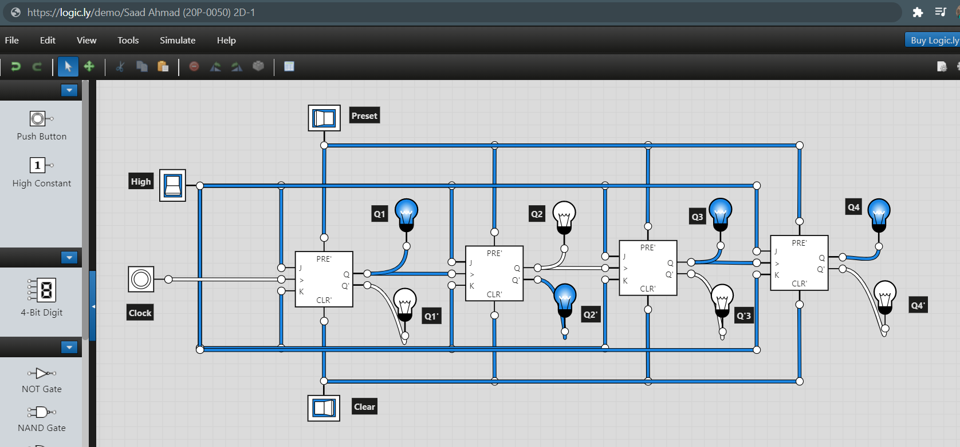

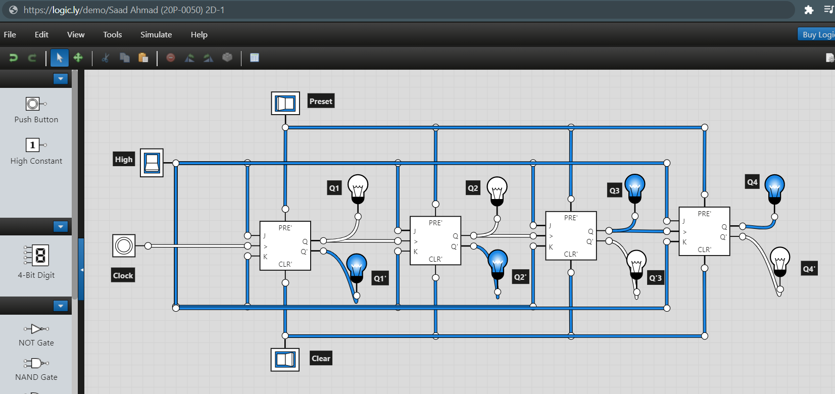

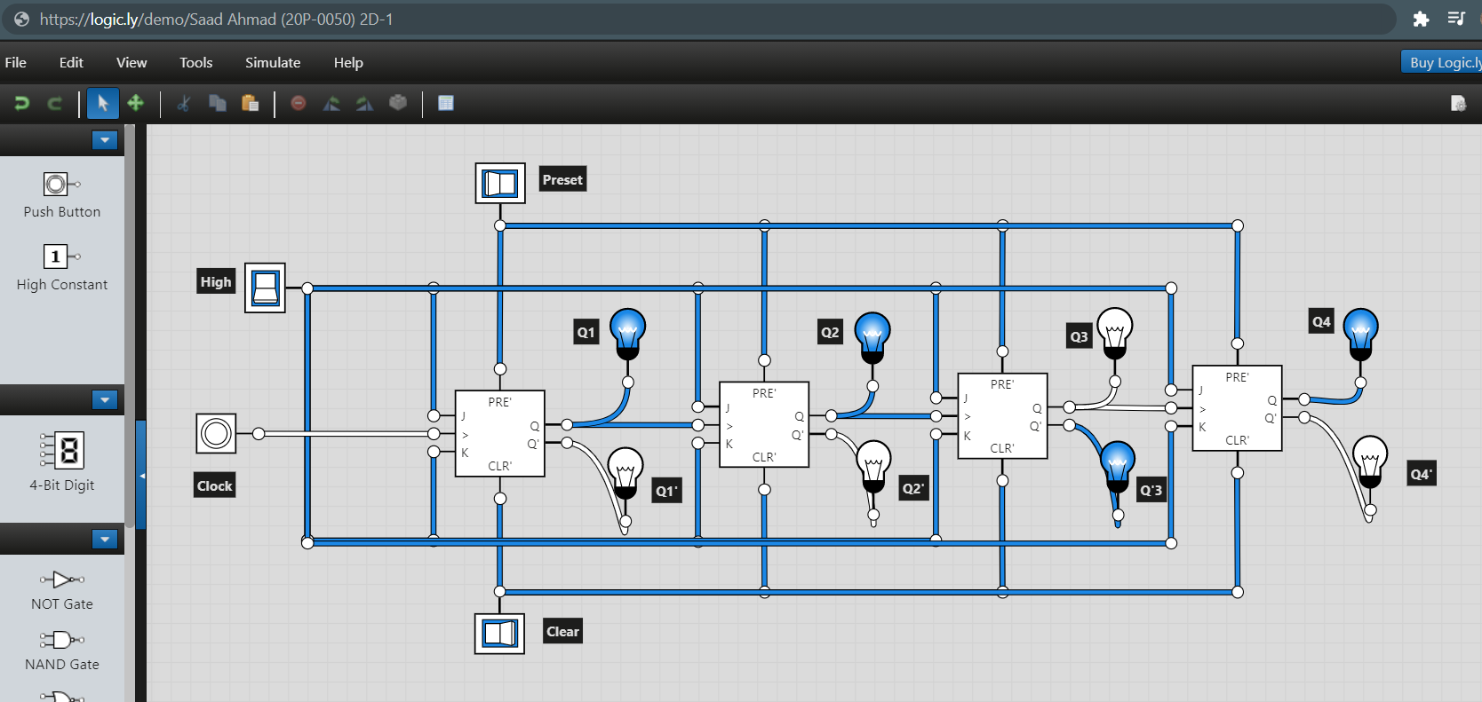

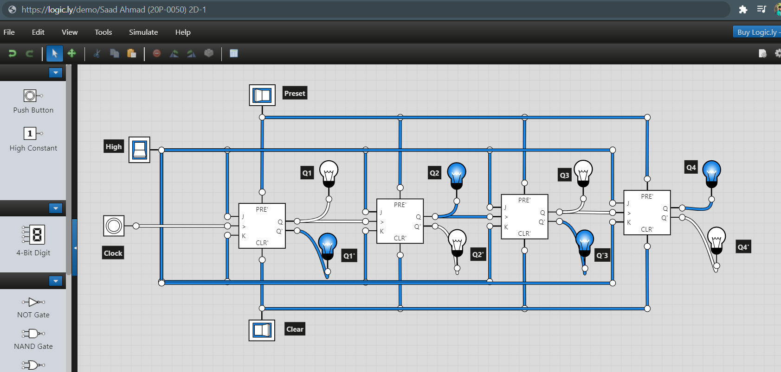

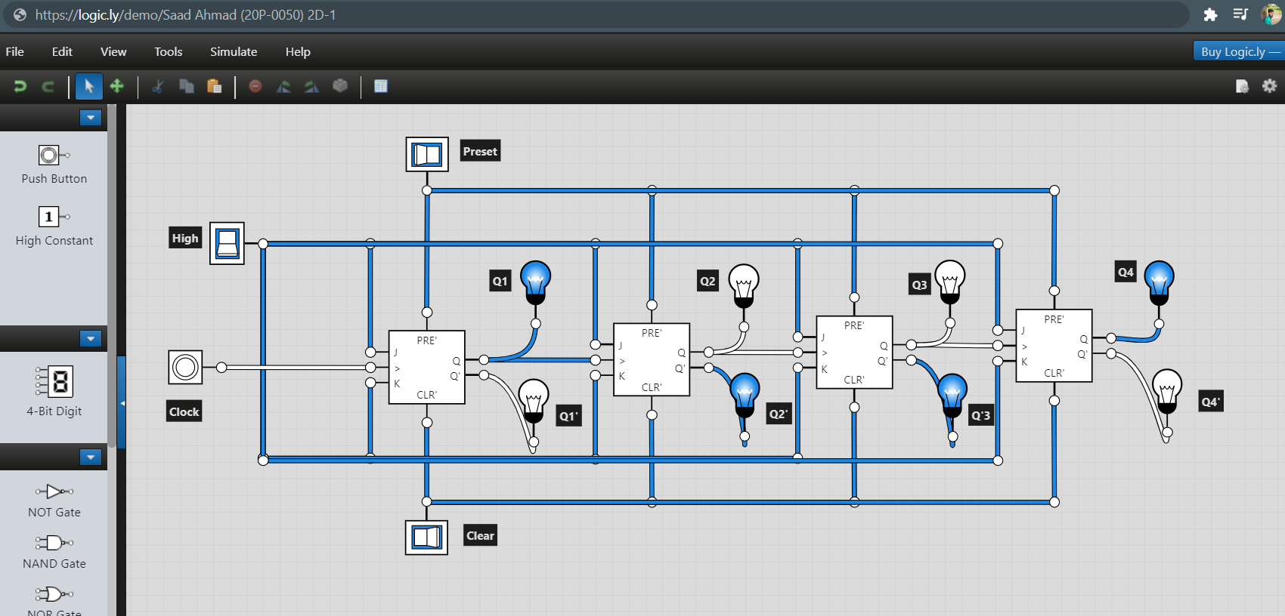

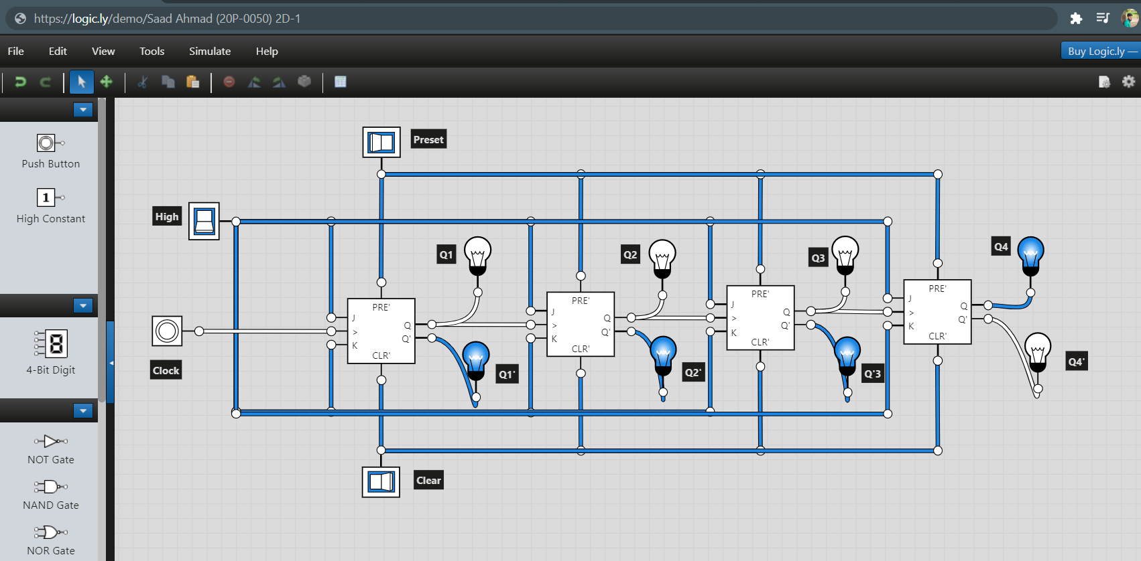

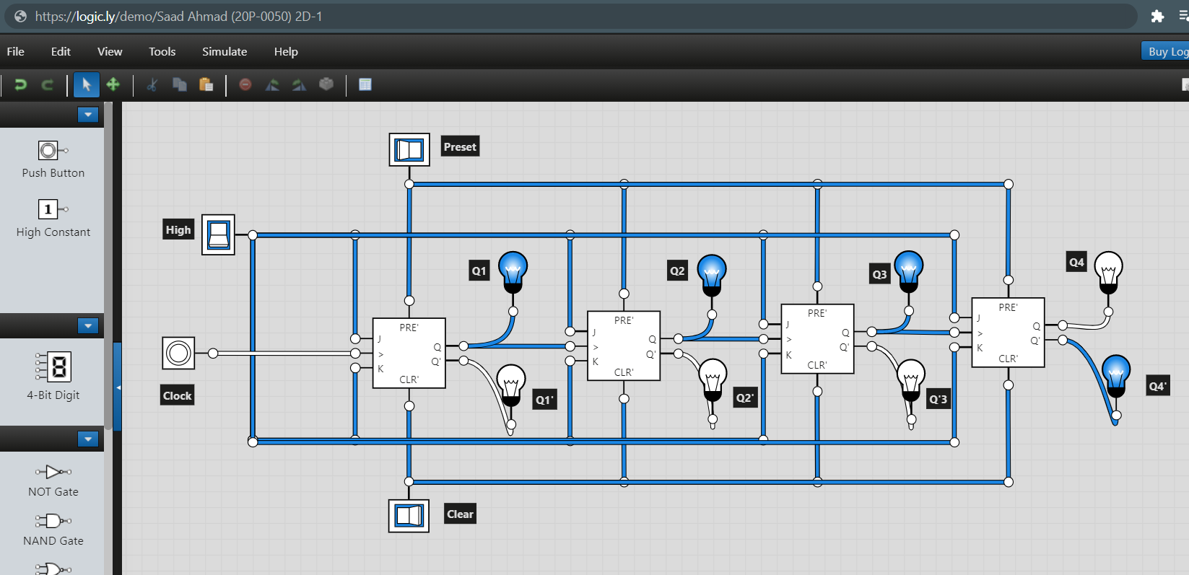

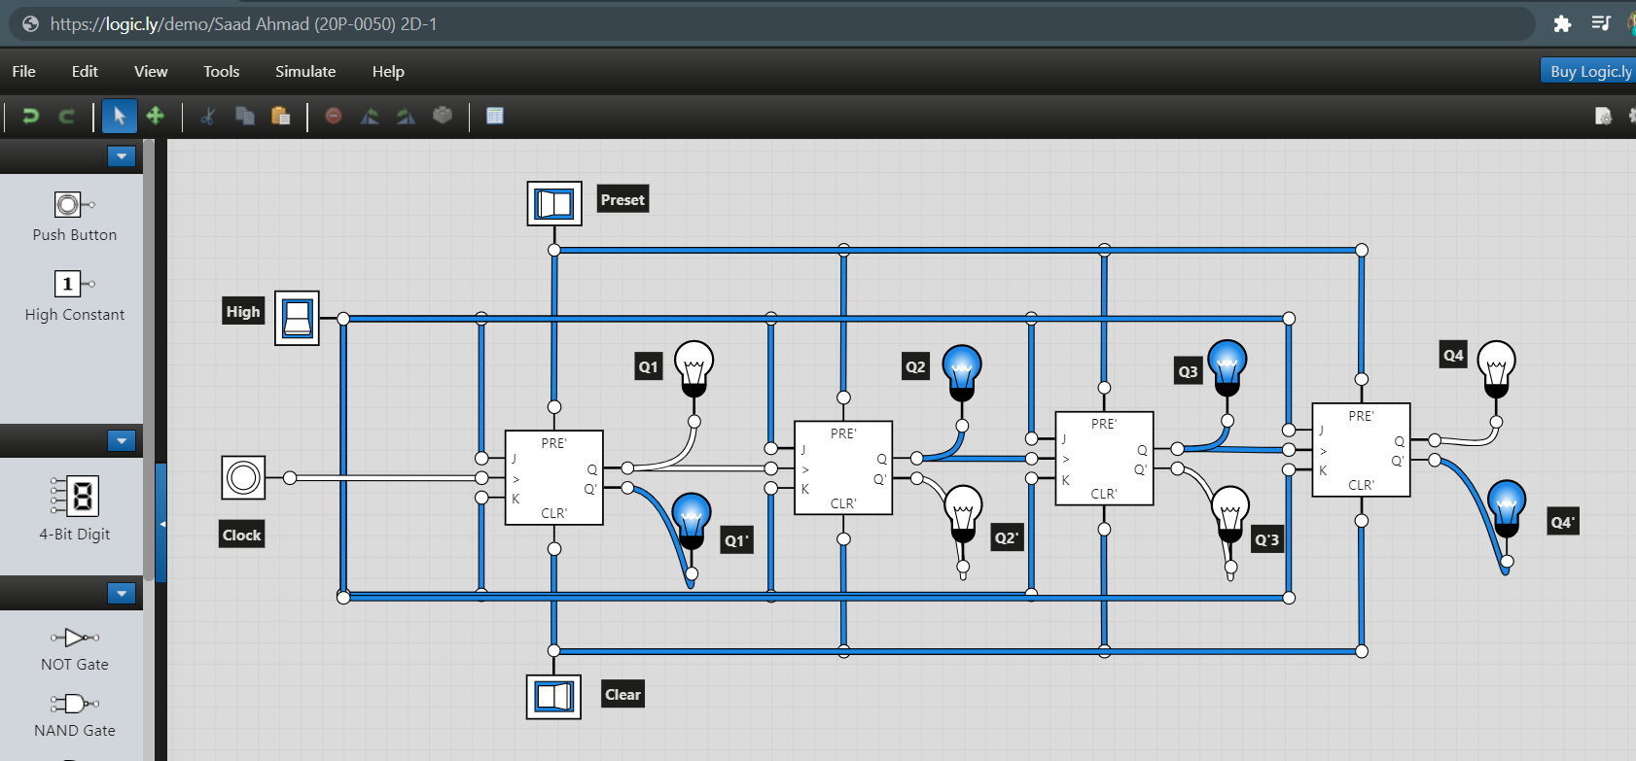

1. **Construct a logic circuit for 3-bit Synchronous Counter using JK Flip Flop. Simulate your circuit to verify the outputs.**
2. Logic Diagram

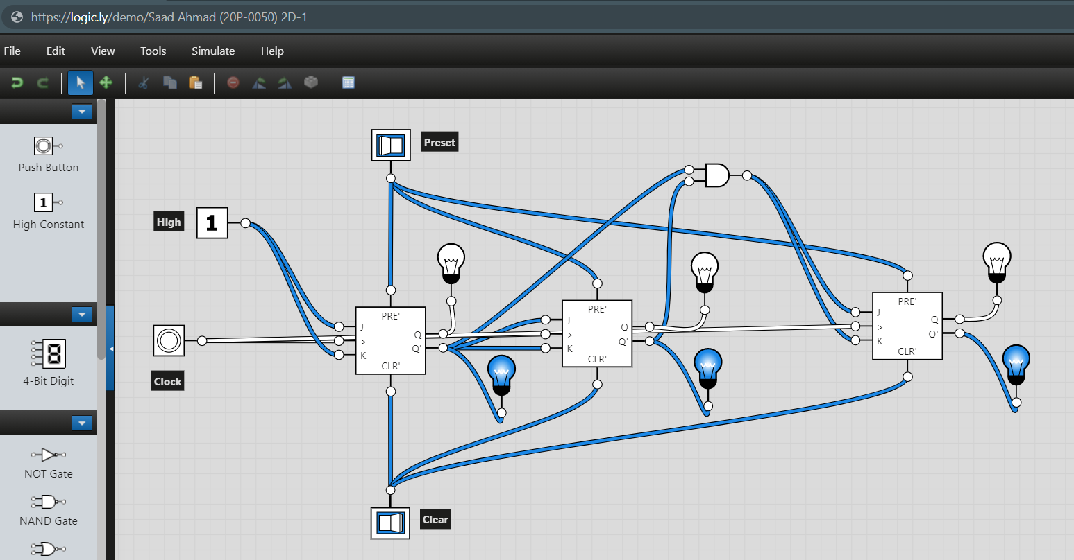

1. Truth Table

|  |  |  |  |  |  |  |  |
| --- | --- | --- | --- | --- | --- | --- | --- |
| Clock | Decimal | Q1 | Q2 | Q3 | Q1’ | Q2’ | Q3’ |
|  | 0 | 0 | 0 | 0 | 1 | 1 | 1 |
|  | 1 | 0 | 0 | 1 | 1 | 1 | 0 |
|  | 2 | 0 | 1 | 0 | 1 | 0 | 1 |
|  | 3 | 0 | 1 | 1 | 1 | 0 | 0 |
|  | 4 | 1 | 0 | 0 | 0 | 1 | 1 |
|  | 5 | 1 | 0 | 1 | 0 | 1 | 0 |
|  | 6 | 1 | 1 | 0 | 0 | 0 | 1 |
|  | 7 | 1 | 1 | 1 | 0 | 0 | 0 |

1. Software Simulation

